
SOUTH EAST EDUCATION DIVISION EXAMINATIONS

2026 MALAWI SCHOOL CERTIFICATE OF EDUCATION MOCK EXAMINATION

AGRICULTURE
Subject Number: M012/I
Monday, 16 March Time Allowed: 2 hours
8:00 - 10:00 am
PAPER I
(100 marks)
Theory
Instructions:

- This paper contains 11 printed pages. Please check.
Question Number | Tick if answered | Do not write in these columns
1
2
3
4
5
6
7
8
9
10
11
12
13
- Write your Examination number at the top of each page.
- This paper has two sections, A and B. Section A has ten questions and section B there are three questions.
- Answer all questions in the spaces provided.
- The maximum number of marks for each answer is indicated against each question.
- In the table provided on this page, tick against the number of the question you have answered.
- At the end of the examination, hand in your question paper to the invigilator.

©2026 SEED MOCK Turn over

SECTION A (70 MARKS)
Instruction: Answer all the questions in this Section in the spaces provided
- a. Describe how each of the following enterprise combination affects agricultural
production.
- Supplementary
__________________________________________________________________________________________________________________________________________________(2 marks)
- Competitive enterprise
__________________________________________________________________________________________________________________________________________________(2 marks)
b. State any two advantages of organic farming
__________________________________________________________________________________________________________________________________________________ (2 marks)

- a. Mention any two examples of animal drawn implements commonly used in Malawi
_____________________________________________________________________________ _____________________________________________________________________ (2 marks)

b. Explain any two importance of Agricultural development agencies to the growing population
____________________________________________________________________________________________________________________________________________________________________________________________________________________________________________________________________________________________________________________________________________________________________________________________ (4 marks)

- a. Mr. Smart bought 10 bags of rice from farmers at MK20,000 per bag. He then spent
MK32, 000 for transport and MK 8,000 for casual labour. He finally sold the rice to the
consumer and made a profit of MK8,000

- Draw the marketing channel displayed in the information above

(2 marks)
- Mention the type of marketing channel drawn in question 3 a. above
____________________________________________________________________________________________________________________________________________________ (1 mark)
- Calculate the total marketing cost incurred in the channel

(3 marks)

Continued/…

- Figure 1 below is a diagram showing a livestock parasite. Use it to answer the
questions that follow
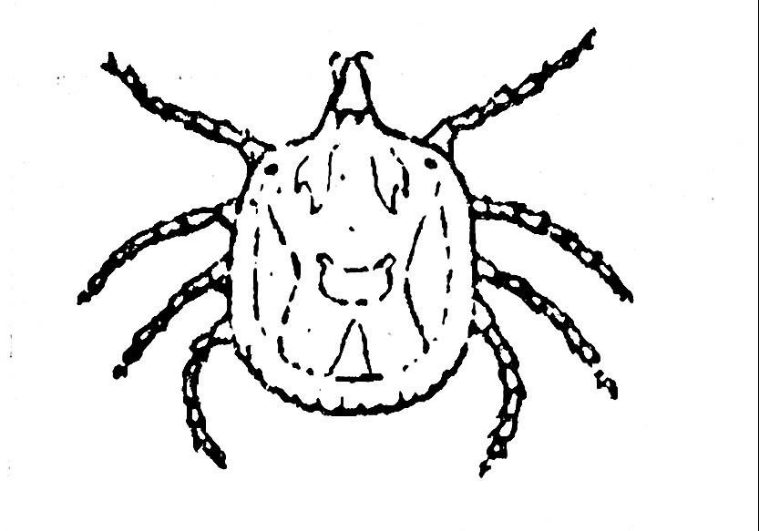
Figure 1
- Identify the parasite above
_____________________________________________________________________ (1 mark)
- Mention any two diseases that are transmitted by the above parasite
__________________________________________________________________________________________________________________________________________________ (2 marks)
- State any two ways of controlling the parasite
___________________________________________________________________________________________________________________________________________________ (2 marks)

- A farmer kept the following information at Tadzuka Farm. Use the information to answer
the questions that follow
Debtors | MK 200, 000
Cash at the bank | MK 1, 200,000
Value of land | MK 2,000, 000
Tax Payable | MK 1, 500, 000
Cash at hand | MK 1, 300, 000
Mortgage | MK 9,000,000

a. Prepare a balance sheet for the farmer

(5 marks)
b. Give any two importance of financial records to the farmer
___________________________________________________________________________________________________________________________________________________ (2 marks)

- a. Mention any two methods which farmers can use to drain land
___________________________________________________________________________________________________________________________________________________ (2 marks)

Continued/…
b. Explain any two importance of draining land agricultural production
____________________________________________________________________________________________________________________________________________________________________________________________________________________________________________________________________________________________________________________________________________________________________________________________ (4 marks)
c. Explain any two importance of rotational grazing in livestock production
_____________________________________________________________________________________________________________________________________________________________________________________________________________________________________________________________________________________________________________________________________________________________________________________________ (4 marks)

- a. State the significance of selfing parental lines during plant breeding?
______________________________________________________________________ (1 mark)
b. Explain any two aims of crop improvement
_____________________________________________________________________________________________________________________________________________________________________________________________________________________________________________________________________________________________________________________________________________________________________________________________ (4 marks)

- A farmer has Malawian Zebu Cattle at the farm and he wants to breed them. Below is a
diagram showing the breeds of the animals.
Malawi Zebu X Malawi Zebu

Offspring

- Name the breeding system above
______________________________________________________________________ (1 mark)
- Mention any two disadvantages of the above livestock breeding system
___________________________________________________________________________________________________________________________________________________ (2 marks)
- Calculate the seed rate of pasture crop whose seed size is 100, 000 kg, 80% of purity and
germination is 70%. The expected plant population is 500,000

(4 marks)

- a. State any two safety measures to be observed when using farm machinery
____________________________________________________________________________________________________________________________________________________(2 marks)
Continued/…
b. Describe any two factors that influence the nutrient status of the soil
__________________________________________________________________________________________________________________________________________________________________________________________________________________________________________________________________________________________________________________________________________________________________________________________________________________________________________________________________________________________________________________________________________________________(4 marks)
c. State any two ways of improving output from human power in Irish Potato field
____________________________________________________________________________________________________________________________________________________(2 marks)

- a. Describe any two factors that affect the quality of conserved pasture
_____________________________________________________________________________________________________________________________________________________________________________________________________________________________________________________________________________________________________________________________________________________________________________________________ (4 marks)
b. Explain any two ways in which mixed cropping can help to conserve soil
_____________________________________________________________________________________________________________________________________________________________________________________________________________________________________________________________________________________________________________________________________________________________________________________________ (4 marks)

c. State any two ways in which processing services are important to the growing
population
___________________________________________________________________________________________________________________________________________________ (2 marks)
Continued/…

SECTION B (30 MARKS)
ESSAYS
Answer all questions in Essay form

- Explain any five ways in which rapid population growth leads to degraded soils
__________________________________________________________________________________________________________________________________________________________________________________________________________________________________________________________________________________________________________________________________________________________________________________________________________________________________________________________________________________________________________________________________________________________________________________________________________________________________________________________________________________________________________________________________________________________________________________________________________________________________________________________________________________________________________________________________________________________________________________________________________________________________________________________________________________________________________________________________________________________________________________________________________________________________________________________________________________________________________________________________________________________________________________________________________________________________________________________________________________________________________________________________________________________________________________________________________________________________________________________________________________________________________________________________________________________________________________________________________________________________________________________________________________________________________________________________________________________________________________________________________________________________________________________________________________________________(10 marks)
- Explain any five ways in which pasture production is important
__________________________________________________________________________________________________________________________________________________________________________________________________________________________________________________________________________________________________________________________________________________________________________________________________________________________________________________________________________________________________________________________________________________________________________________________________________________________________________________________________________________________________________________________________________________________________________________________________________________________________________________________________________________________________________________________________________________________________________________________________________________________________________________________________________________________________________________________________________________________________________________________________________________________________________________________________________________________________________________________________________________________________________________________________________________________________________________________________________________________________________________________________________________________________________________________________________________________________________________________________________________________________________________________________________________________________________________________________________________________________________________________________________________________________________________________________________________________________________________________________________________________________________________________________________________________________________________________________________________________________________________________ (10 marks)

- Explain any five causes of gender bias in agricultural production
____________________________________________________________________________________________________________________________________________________________________________________________________________________________________________________________________________________________________________________________________________________________________________________________________________________________________________________________________________________________________________________________________________________________________________________________________________________________________________________________________________________________________________________________________________________________________________________________________________________________________________________________________________________________________________________________________________________________________________________________________________________________________________________________________________________________________________________________________________________________________________________________________________________________________________________________________________________________________________________________________________________________________________________________________________________________________________________________________________________________________________________________________________________________________________________________________________________________________________________________________________________________________________________________________________________________________________________________________________________________________________________________________________________________________________________________________________________________________________________________________________________________________________________________________________________________________________ (10 marks)

END OF QUESTION PAPER
NB: This paper contains 11 printed pages.

